26.15: a) 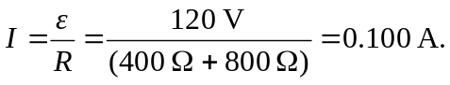
b)

c) When in parallel, the equivalent resistance becomes:
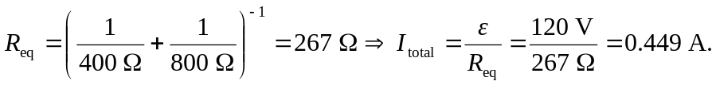
d)

e) The 800  resistor is brighter when the resistors are in series, and the 400 is brighter when in parallel. The greatest total light output is when they are in parallel.

